AM000-Asia-China-Han-Two Philosopher and Student-Four Lotus Flowers-Two Tigers

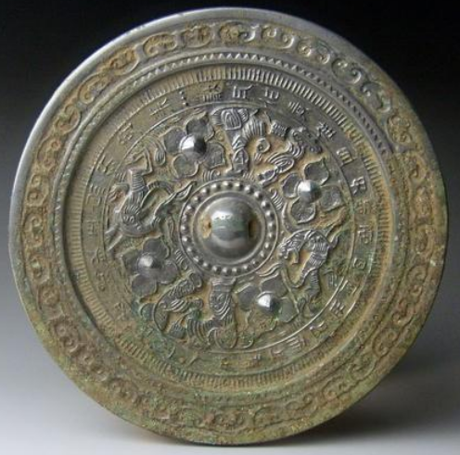

Han Period (206 BC – 220 CE), high zinc (due to silvery finish) bronze mirror.

This unusual mirror shows two views of a philosopher and a student separated by rampant animals.

It appears that the philosopher is presenting a poem to a student, who looks attentively at his master.

The theme is an ancient one that goes back to Confucian times. It suggests that the pursuit of patient study is constantly challenged by the unstoppable flight of time as personified in the form of ferocious rampant tigers that incessantly pursue the teacher and his student around the central boss. In the outer band is a lengthy poem relating to this theme. [Needs expert translation and an attribution.] Around the outer rim of the mirror is a band of cloud lozenges suggesting eternity and on the inner band is hachuring suggesting the tick-tick of the clock-world.

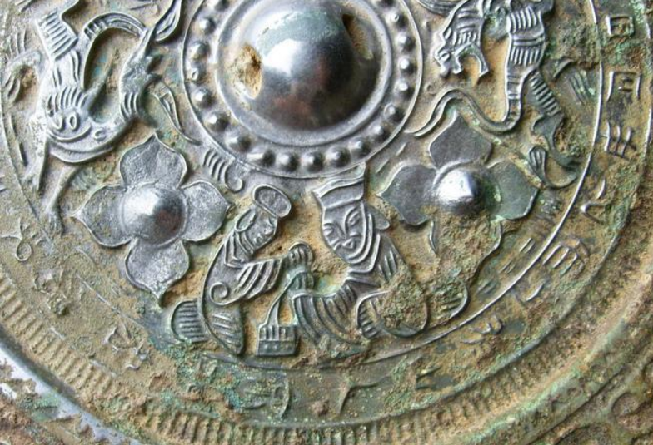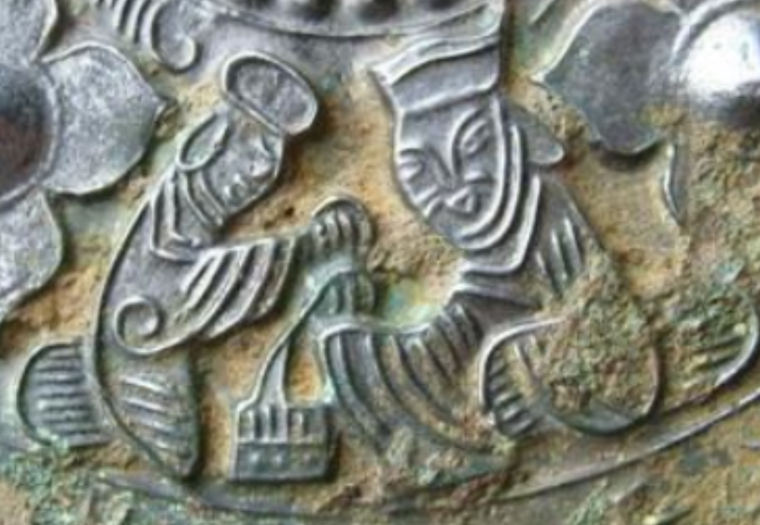

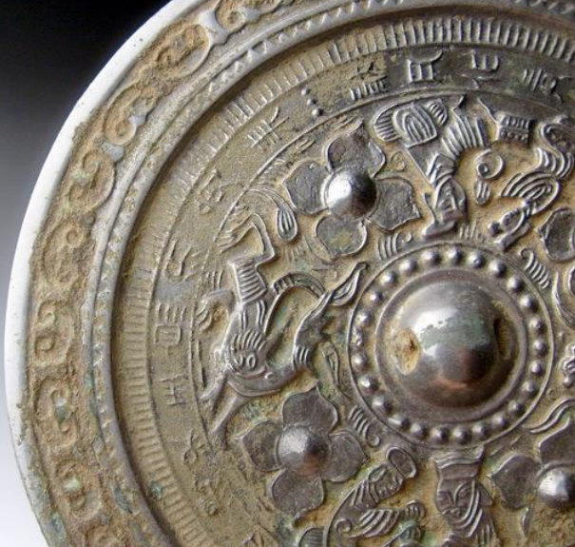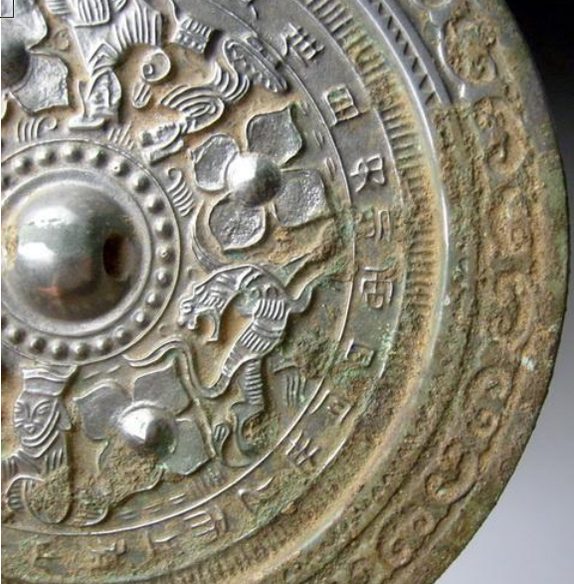

# Han Dynasty dragon&tiger grass inscriptions bronze mirror 7inch*780g